**C++ ASSIGNMENT 5 (STRING HANDLING)**

1. **Write a program to find the length of string.**

**Code**

1. #include <iostream>
2. #include <string>
3. using namespace std;
4. void Length(string s)
5. {
6. int n = s.length();
7. cout << "Length of String = "<< n;
8. }
9. int main()
10. {
11. string s;
12. cout << "Enter String Value = ";
13. getline(cin,s);
14. Length(s);
15. }

**Output**

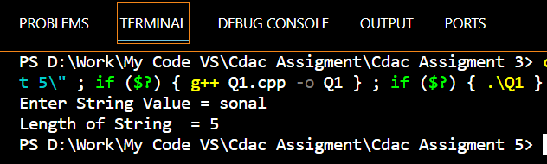

1. **Write a program to display string from backward.**

**Code**

1. #include <iostream>
2. #include <string>
3. using namespace std;
4. void ReverseStr(string s)
5. {
6. int i;
7. int n = s.length();
8. for(i=(n-1);i>=0;i--)
9. {
10. cout << s[i] ;
11. }
12. }
13. int main()
14. {
15. string s;
16. cout << "Enter String Value = ";
17. getline(cin,s);
18. ReverseStr(s);
19. }

**Output**

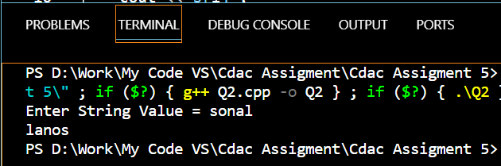

1. **Write a program to count number of words in string.**

**Code**

1. #include <iostream>
2. #include <string>
3. using namespace std;
4. void CountWords(string s)
5. {
6. int i;
7. int j = 0;
8. int n = s.length();
9. for(i=(n-1);i>=0;i--)
10. {
11. if(s[i]==' ')
12. {
13. j++;
14. }
15. }
16. cout << "Number of words = "<<(j+1);
17. }
18. int main()
19. {
20. string s;
21. cout << "Enter String Value = ";
22. getline(cin,s);
23. CountWords(s);
24. }

**Output**

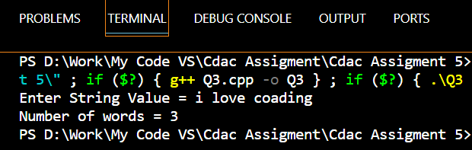

1. **Write a program to concatenate one string contents to another.**

**Code**

1. #include <iostream>
2. #include <string>
3. using namespace std;
4. void Concatenate(string s1,string s2)
5. {
6. string s;
7. s = s1+ " "+s2;
8. cout << s ;
9. }
10. int main()
11. {
12. string s1,s2;
13. cout << "Enter String Content 1 = ";
14. getline(cin,s1);
15. cout << "Enter String Content 2 = ";
16. getline(cin,s2);
17. Concatenate(s1,s2);
18. }

**Output**

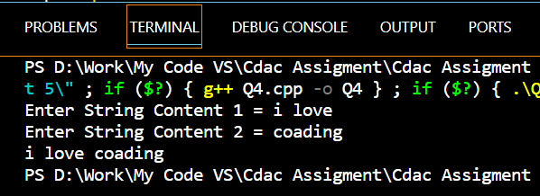

1. **Write a program to compare two strings they are exact equal or not.**

**Code**

1. #include <iostream>
2. #include <string>
3. using namespace std;
4. void Compare(string s1,string s2)
5. {
6. string s;
7. if(s1==s2)
8. {
9. cout << "Strings are Equal" ;
10. }
11. else
12. {
13. cout << "Strings are not Equal" ;
14. }
15. }
16. int main()
17. {
18. string s1,s2;
19. cout << "Enter String Content 1 = ";
20. getline(cin,s1);
21. cout << "Enter String Content 2 = ";
22. getline(cin,s2);
23. Compare(s1,s2);
24. }

**Output**

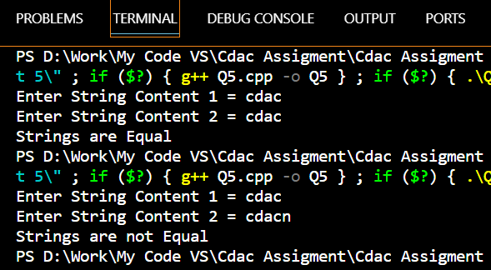

1. **Write a program to check a string is palindrome or not.**

**Code**

1. #include <iostream>
2. #include <string>
3. using namespace std;
4. void PalindromeString(string s)
5. {
6. string r;
7. int i;
8. int n = s.length();
9. for(i=(n-1);i>=0;i--)
10. {
11. r = r + s[i] ;
12. }
13. if(s==r)
14. {
15. cout << "Palindrome String";
16. }
17. else
18. {
19. cout << "Not a Palindrome String";
20. }
21. }
22. int main()
23. {
24. string s;
25. cout << "Enter String Value = ";
26. getline(cin,s);
27. PalindromeString(s);
28. }

**Output**

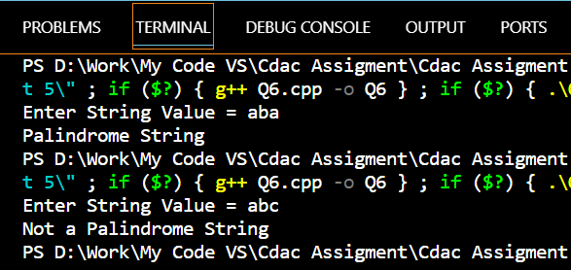

1. **Write a program to find a substring within a string. If found display its starting position.**

**Code**

1. #include <iostream>
2. #include <string>
3. using namespace std;
4. void SubString(string s1,string s2)
5. {
6. int n = s1.find(s2);
7. if (n>=0)
8. {
9. cout << "Index Value at which SubString if found = " <<n;
10. }
11. else
12. {
13. cout << "No SubString Found" ;
14. }
15. }
16. int main()
17. {
18. string s1,s2;
19. cout << "Enter String Value = ";
20. getline(cin,s1);
21. cout << "Enter SubString Value = ";
22. getline(cin,s2);
23. SubString(s1,s2);
24. }

**Output**

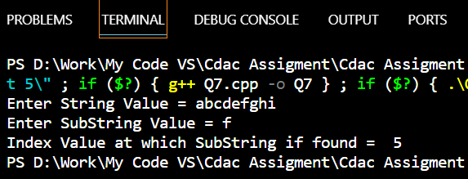

1. **Write a program to reverse a string.**

**Code**

1. #include <iostream>
2. #include <string>
3. using namespace std;
4. void ReverseString(string s)
5. {
6. int First,Last;
7. int n = s.length();
8. First = 0;
9. Last = n-1;
10. while(First<Last)
11. {
12. swap(s[First++],s[Last--]);
13. }
14. cout << s;
15. }
16. int main()
17. {
18. string s;
19. cout << "Enter String Value = ";
20. getline(cin,s);
21. ReverseString(s);
22. }

**Output**

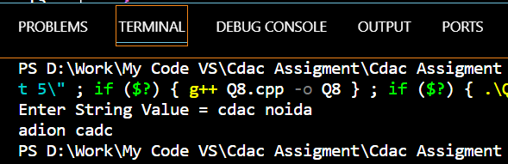

1. **Write a program to convert a string in lowercase.**

**Code**

1. #include <iostream>
2. #include <string>
3. using namespace std;
4. void LowerCase(string s)
5. {
6. int i;
7. string r;
8. int n = s.length();
9. for(i=0;i<=(n-1);i++)
10. {
11. r = tolower(s[i]);
12. cout << r ;
13. }
14. }
15. int main()
16. {
17. string s;
18. cout << "Enter String Value = ";
19. getline(cin,s);
20. LowerCase(s);
21. }

**Output**

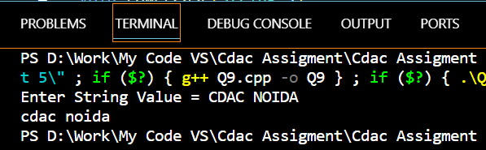

1. **Write a program to convert a string in uppercase.**

**Code**

1. #include <iostream>
2. #include <string>
3. using namespace std;
4. void UpperCase(string s)
5. {
6. int i;
7. string r;
8. int n = s.length();
9. for(i=0;i<=(n-1);i++)
10. {
11. r = toupper(s[i]);
12. cout << r ;
13. }
14. }
15. int main()
16. {
17. string s;
18. cout << "Enter String Value = ";
19. getline(cin,s);
20. UpperCase(s);
21. }

**Output**

